VIETNAM GENERAL CONFEDERATION OF LABOUR

**TON DUC THANG UNIVERSITY**

**FACULTY OF INFORMATION TECHNOLOGY**



**FINAL REPORT SOFTWARE ENGINEERING**

**Hotel Management**

*Instructor:* **DANG MINH THANG**

*Performers:* **Ta Trung Hieu – 518H0502**

**Nguyen Thi Lan Anh – 518H0000**

**Tran Thi Hong Tuyet Ngan – 518H0000**

Course  **: 22**

**HO CHI MINH CITY, 2020**

VIETNAM GENERAL CONFEDERATION OF LABOUR

**TON DUC THANG UNIVERSITY**

**FACULTY OF INFORMATION TECHNOLOGY**



**FINAL REPORT SOFTWARE ENGINEERING**

**Hotel Management**

*Instructor:* **DANG MINH THANG**

*Performers:* **Ta Trung Hieu – 518H0502**

**Nguyen Thi Lan Anh – 518H0000**

**Tran Thi Hong Tuyet Ngan – 518H0000**

Course  **: 22**

**HO CHI MINH CITY, 2020**

THANK YOU

Thank you, Mr. Dang Minh Thang, for guiding us to make this report.

**THIS PROJECT IS COMPLETED AT TON DUC THANG UNIVERSITY**

I hereby guarantee that this is a product of our project and under the guidance of teacher Dang Minh Thang. The research contents and results in this topic are truthful and have not been published in any form before. The data in the tables for analysis, comments and evaluation collected by the author from different sources are clearly stated in the references.

In addition, the project also uses a number of comments, reviews as well as data of other authors, and other organizations and organizations have cited and noted origin.

**If I detect any fraud I take full responsibility for the content of my project.** Ton Duc Thang University is not related to copyright or copyright infringement caused by me in the implementation process (if any).

*Ho Chi Minh City, day month year*

*Author*

*(Sign and write full name)*

*Tạ Trung Hiếu*

*Trần Thị Hồng Tuyết Ngân*

*Nguyễn Thị Lan Anh*

TEACHER'S CONFIRMATION AND EVALUATION SECTION

**Instructor's confirmation section**

_______________________________________________________________________________________________________________________________________________________________________________________________________________________________________________________________________________________________________________________________________________________________________________________________________________

Ho Chi Minh City, day month year

(Sign and write full name)

**The teacher evaluation section**

_______________________________________________________________________________________________________________________________________________________________________________________________________________________________________________________________________________________________________________________________________________________________________________________________________________

Ho Chi Minh City, day month year

(Sign and write full name)

SUMMARY

Trình bày tóm tắt vấn đề nghiên cứu, các hướng tiếp cận, cách giải quyết vấn đề và một số kết quả đạt được, những phát hiện cơ bản trong vòng 1 -2 trang.

TABLE OF CONTENTS

THANK YOU i

TEACHER'S CONFIRMATION AND EVALUATION SECTION iv

SUMMARY v

TABLE OF CONTENTS 1

LIST OF TABLES, FIGURES, GRAPHICS 4

CHAPTER 1 – REQUIREMENTS ENGINEERING 5

1.1 Project Overview 5

1.2 Analyze customer requirements 5

1.3 Interview and collect form 6

1.4 Functional Requirements 7

1.4.1 Function requirement 7

1.4.2 Non-functional requirement 7

CHAPTER 2. SYSTEM DIAGRAM DESIGN 8

2.1 Use case diagrams 8

2.2 Class diagrams 8

2.3 Activity diagrams 8

2.4 Sequence diagrams 10

CHAPTER 3. DATABASE DESIGN 12

3.1 Entity Relationship Diagram (ERD) 12

3.2 Relational Data Model 13

CHAPTER 4. SOFTWARE IMPLEMENTATION 14

4.1 UI Design 14

4.2 Coding Convention 14

CHAPTER 5. APPLICATION DEVELOPMENT TOOLS 16

5.1 Implement Test Cases and Unit Test 16

5.2 Git and Github 16

SELF ASSESSMENT 17

REFERENCES 19

**LIST OF SIGNS AND ABBREVIATIONS**

**SIGNALS**

*f Tần số của dòng điện và điện áp (Hz)*

*p Mật độ điện tích khối (C/m3)*

**ABBREVIATIONS**

CSTD Công suất tác dụng

MF Máy phát điện

BER Tỷ lệ bít lỗi

LIST OF TABLES, FIGURES, GRAPHICS

**LIST OF FIGURES**

Hình 2.1: Kiến trúc FTP 2

**LIST OF TABLES**

Bảng 3.1 Ví dụ cho chèn bảng 2

CHAPTER 1 – REQUIREMENTS ENGINEERING

* 1. Project Overview

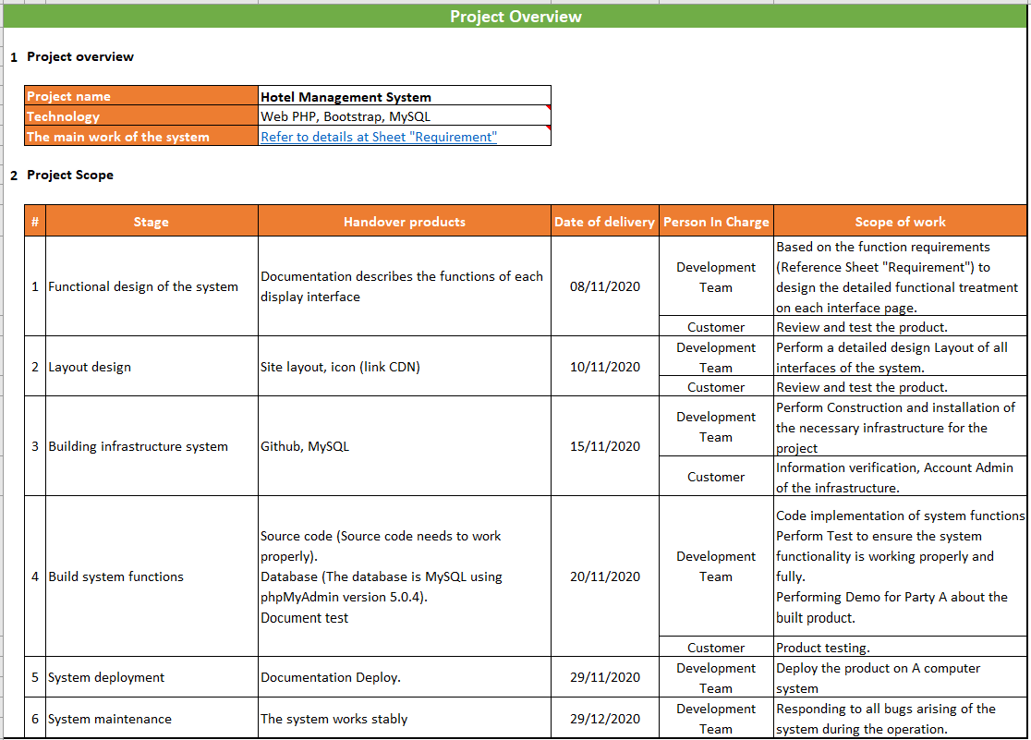

* 1. Analyze customer requirements

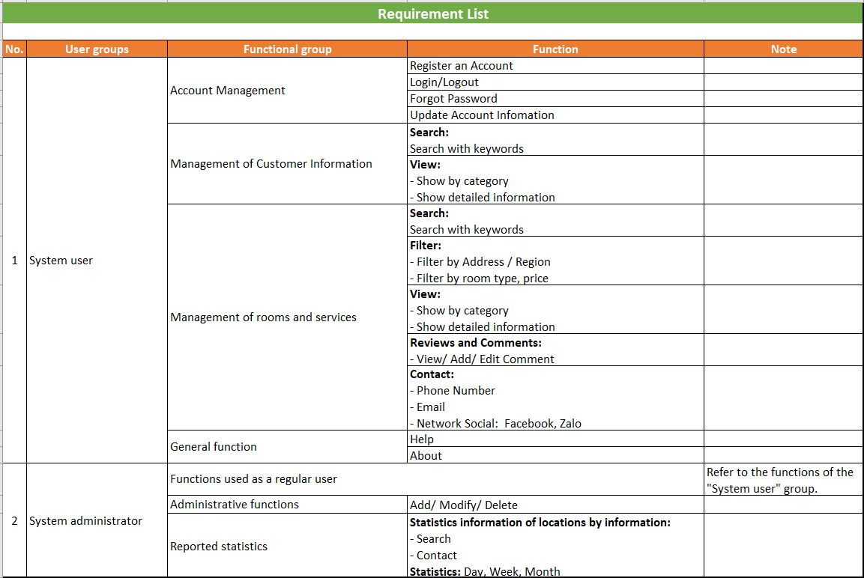

* 1. Interview and collect form
* Tool: Google Meet
* Record Metting: Yes
* Language: Vietnamese
* Interpreters: No
* Share Document: Microsoft Office + One Drive

|  |  |  |  |
| --- | --- | --- | --- |
| No. | Section/ Screen | Comment/ Question | Answer |
| 1 | Form Login |  |  |
| 2 | Home page interface |  |  |
| 3 | Room view (detail) interface |  |  |
| 4 | Booking interface |  |  |
| 5 | Customer management interface |  |  |
| 6 | Employee management interface |  |  |
| 7 | Infomation & Help interface |  |  |

* 1. Functional Requirements
     1. Function requirement
     2. Non-functional requirement

CHAPTER 2. SYSTEM DIAGRAM DESIGN

2.1 Use case diagrams

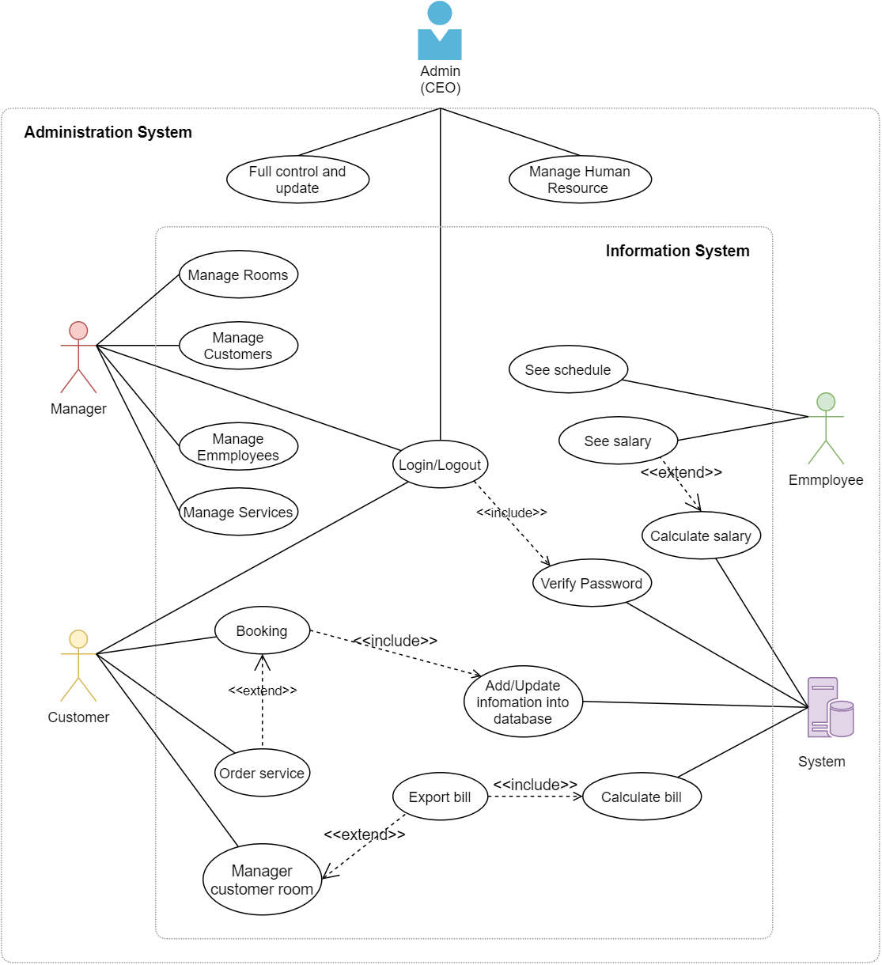

2.2 Class diagrams

2.3 **Activity diagrams**

Login Activity:

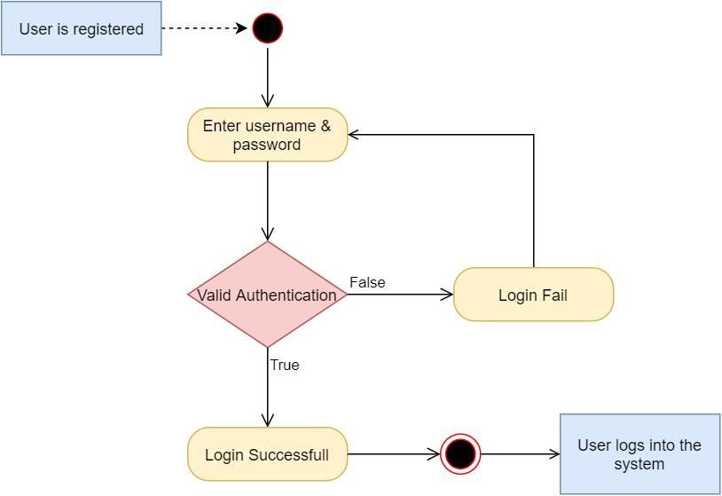

Booking Activity:

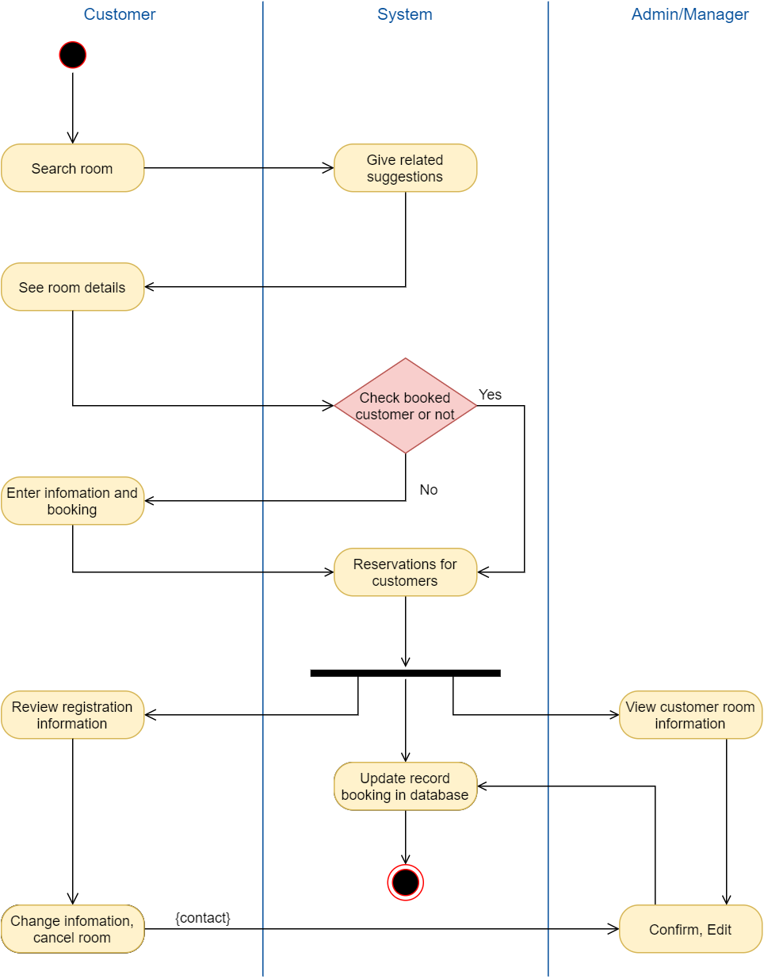

2.4 Sequence diagrams

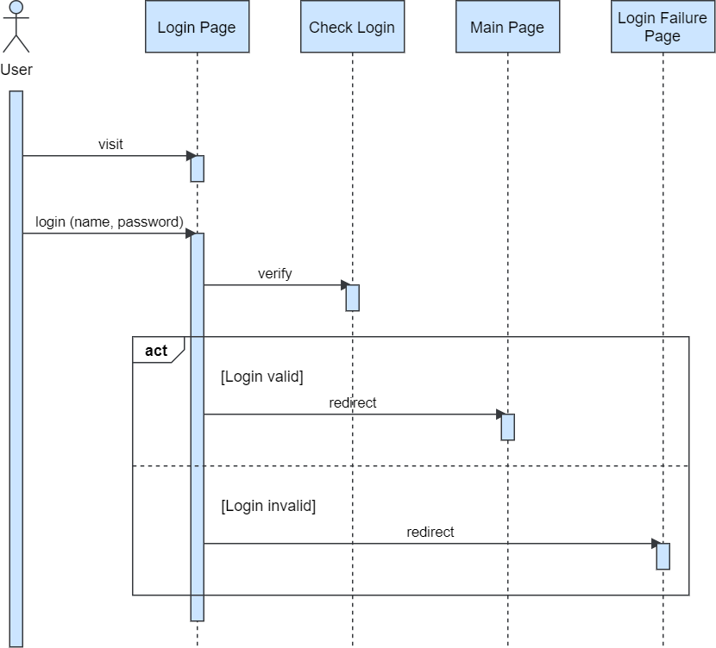

CHAPTER 3. DATABASE DESIGN

3.1 Entity Relationship Diagram (ERD)

Crow’s foot notation uses some unique shapes and symbols to represent the elements in a database. So we use them in ERD, which is a popular model in companies today.

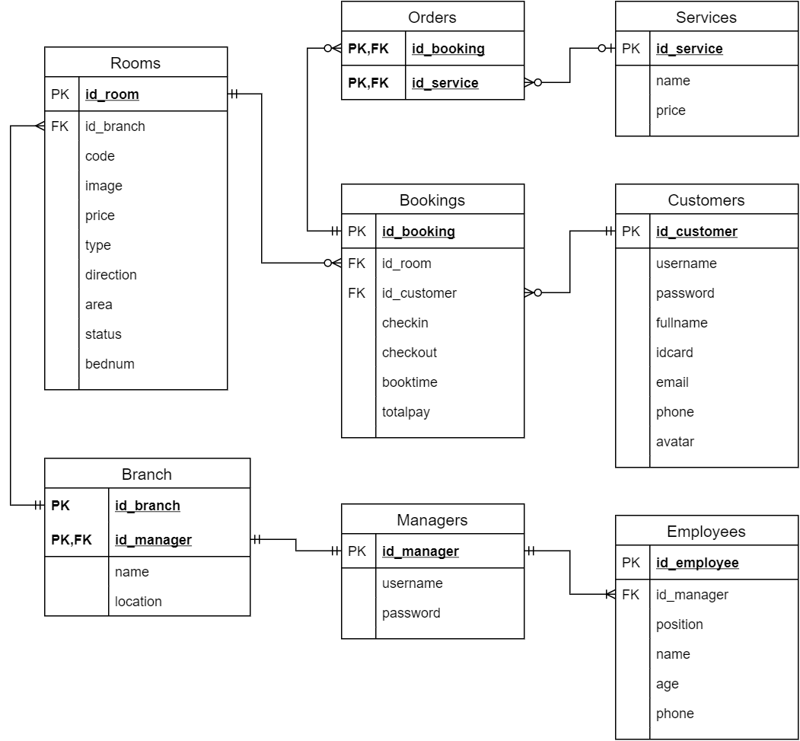

Description - A hotel chain under the administration of Admin includes the following entities:

* Each hotel branch has multiple rooms and is under the management of a single manager.
* Each room in the hotel has 0 or more bookings
* Each customer can book more than one room
* Customers can order more 0 or more services when booking
* Each manager manages only 1 branch
* Each employee is under the sole management of one manager

3.2 Relational Model

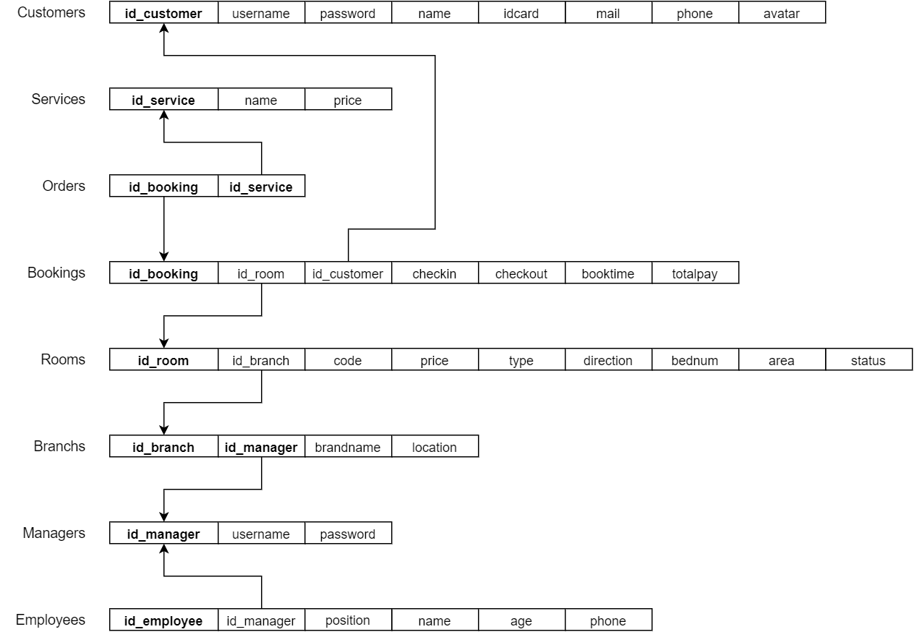

CHAPTER 4. SOFTWARE IMPLEMENTATION

4.1 UI Design

4.2 Coding Convention

Coding conventions is a set of general principles when programming to make the code easy to read, understand, and therefore easier to manage and maintain.

While programming we adhere to the following naming rules:

|  |  |  |
| --- | --- | --- |
|  | Syntax | Example |
| Funcition name | camelCase | displayCustomer() |
| Variable name | snake_case | id_user |

Along with some standard PSR-2 rules are referenced below:

* Use 4 spaces for indentation (Setup in Visual Studio Code):



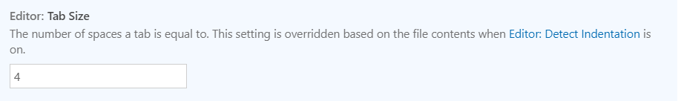



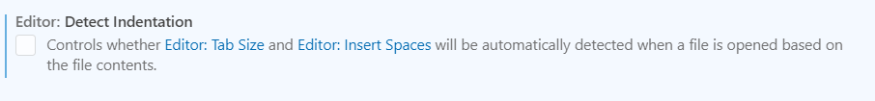

* On a line with no more than 120 characters, there must be no space at the end of the line (except for link and script tags):

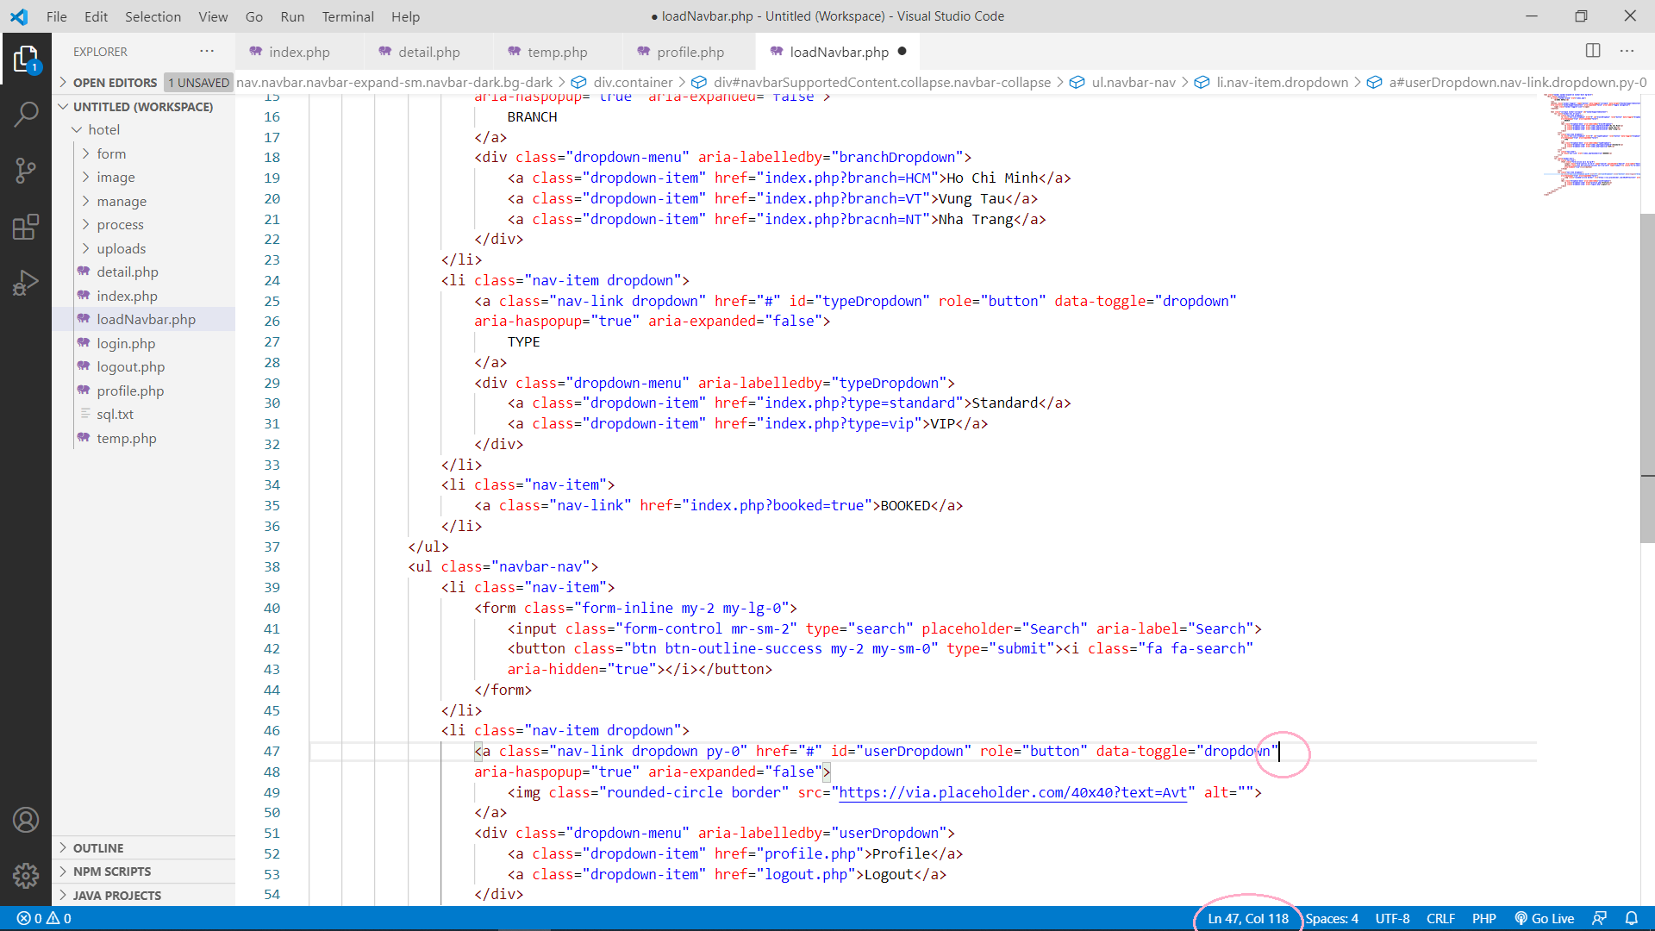

* The opening and closing tags of a function {} must be on a separate line.
* Must use single quotes ‘to declare strings without variables. If the string contains‘, then use quotes to wrap them.
* Use accents. To concatenate strings, pay attention before and after the dot. There must be a space. If the string is too long, split it into multiple lines and a period is placed at the beginning of the line with an equal sign.
* The parameters passed to the function must have a space after the comma

CHAPTER 5. APPLICATION DEVELOPMENT TOOLS

5.1 Implement Test Cases and Unit Test

5.2 Git and Github

SELF ASSESSMENT

*(Vietnamese)*

|  |  |  |  |  |  |  |
| --- | --- | --- | --- | --- | --- | --- |
| **Nội dung tiêu chí** | **Điểm /10** | **Thang đánh giá** | | | **Điểm quy đổi** | **Ghi chú**  *(Tiêu chí đạt được trong file Rubric)* |
| **0 điểm** | **½ tổng điểm** | **Trọn điểm** |
| **Requirements**  **Engineering**  Phân tích yêucầu kháchhàng, phỏngvấn, thu thậpbiểu mẫu, liệtkê những yêucầu chức năngvà yêu cầu phichức năng | **1.0** |  |  | x | 1 | Nội dung rõ ràng,  đầy đủ. |
| **Use case specification and diagrams** | **1.0** |  |  |  |  |  |
| Use case diagrams | 0.5 |  |  | x | 0.5 | Vẽ đúng, đầy đủ các use case và các mối quan hệ trong use case. |
| Đặc tả use case | 0.5 |  | x |  | 0.25 | Có lập bảng đặc tả use case nhưng còn thiếu, sai sót. |
| **Class diagrams** | **1.0** |  | x |  | 0.5 | Có vẽ class diagrams nhưng còn thiếu hoặc sai  sót (không nghiêm trọng). |
| **Activity and sequence diagrams** | **1.0** |  |  |  |  |  |
| Activity diagrams (chỉ chọn vài cái chính) | 0.5 |  |  | x | 0.5 | Vẽ đúng các activity diagrams. |
| Sequence diagrams (chỉ chọn vài cái chính) | 0.5 |  | x |  | 0.25 | Có vẽ sequence diagrams nhưng còn thiếu hoặc sai |
| EntityRelationshipDiagram,RelationalData Model | **1.0** |  |  | x | 1 | Thiết kế đúng đủ ERD, Relational Data Model và mô tả đầy đủ các bảng  trong CSDL |
| Xây dựngứng dụng cóít nhất 4 chứcnăng chính | **2.0** |  |  | x | 2 | Xây dựng ứng dụng hoạt động ổn định, đầy đủ chức năng |
| CodingConvention | **0.5** |  |  | x | 0.5 | Tuân thủ chặt chẽ coding convention |
| Test case,Unit test | **0.5** |  | x |  | 0.25 | Có viết test case hoặc unit test nhưng còn nhiều thiếu sót. |
| SVN/GIT | **1.0** |  |  | x | 1 | Sử dụng SVN/GIT thường xuyên trong quá trình làm đồ án. |
| Hình thứcbáo cáo, trảlời vấn đáp | **1.0** |  |  | x | 1 | Báo cáo trình bày gọn gàng, chặt chẽ. Trả lời vấn đáp tốt. |
| **Tổng** | **10** |  | | | 8.75 |  |

REFERENCES

1. Coding Conventions và các chuẩn viết code trong PHP:

<https://viblo.asia/p/coding-conventions-va-cac-chuan-viet-code-trong-php-naQZRbrGZvx> *(December 4, 2020)*